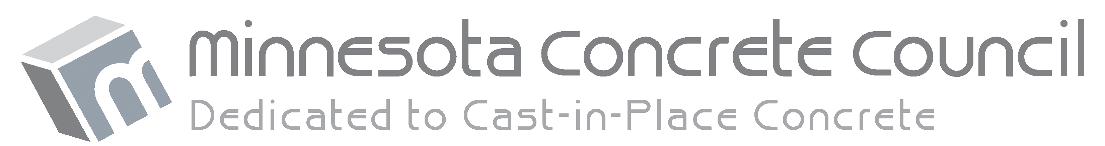
GRANT APPLICATION

THE MINNESOTA CONCRETE COUNCIL (MCC) is dedicated to advancing education, technical practice, and technical certifications for cast-in-place concrete technology by organizing the efforts of its members as a non-profit service organization.
MCC is only able to accomplish its goals through the support of its members, and also recognizes its members have goals that can benefit from MCC’s support. Building on its history of awarding scholarships to worthy engineering or construction management students, MCC is expanding its ability to provide financial support through the creation of a grant program.
MCC is proud to expand its giving program to include grants of up to $1,000 that are intended to provide financial assistance to its members and student organizations who are interested in developing skills, expanding knowledge, or advancing career development in the cast-in-place concrete construction related industry. The Minnesota Concrete Council will consider a wide range of requests for grant funding. If you have questions about your request, please email info@mnconcretecouncil.com

QUALIFICATION CRITERIA
Any MCC member in good standing (or related student organization) is eligible to apply for a grant.

SUBMISSION PROCESS AND TIMELINE
- This application may be downloaded from the MCC website or by e-mailing a request to info@mnconcretecouncil.com
- Completed applications should be submitted via email to info@mnconcretecouncil.com
- Applications will be reviewed on a monthly basis.
- Applicants can expect a response within six to eight weeks of the grant request.
- MCC operates on a January – December fiscal year and has an annual budget for grants. Once the annual budget has been depleted, grant requests may need to be pushed to the next fiscal year.

CONTACT
If you have any questions regarding the grant program, please contact the Minnesota Concrete Council at 651-482-9549 or by e-mail at info@mnconcretecouncil.com
GRANT APPLICATION

CONTACT INFORMATION
Name:
Company or Student Organization:
Mailing Address:
City: State: Zip:
Phone:
Email Address:

GRANT REQUEST DETAILS
To make it easier for MCC to review your request, please be sure to include all relevant information, with as many details as possible, or a response to your request may be delayed.
Amount requested (Maximum $1,000):
What percentage of the total cost is the request?
Date needed:
How will the grant be used?

How will the grant help to develop your skills, expand your knowledge, and advance the development of your career as it relates to cast-in-place concrete?

Please return the completed application via email to info@mnconcretecouncil.com If desired, you may also submit additional supporting information along with the application.

Questions? Email info@mnconcretecouncil.com or call MCC at 651-482-9549

