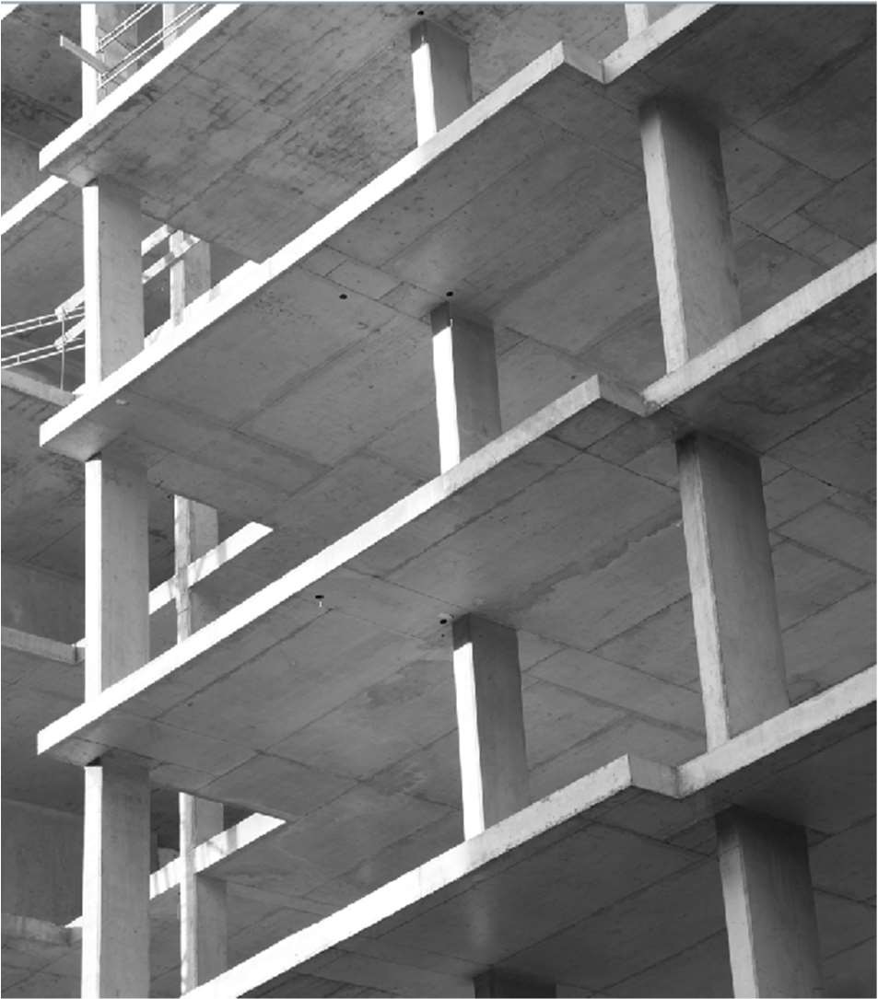

MINNESOTA CONCRETE COUNCIL

THE MINNESOTA CONCRETE COUNCIL (MCC) is dedicated to advancing education, technical practice, scientific investigation and research into cast- in-place concrete materials and construction practices by organizing the efforts of its members as a non-profit service organization. Individual memberships and member companies represent design, construction and support industries associated with reinforced and post-tensioned concrete construction throughout Minnesota. MCC members have national and international presence in the design, construction, forensic, materials, QA/ QC and construction fields. The organization is committed to keeping its members on the leading edge of technology as it relates to their respective disciplines via continuing education programs, networking opportunities and research.

As MCC has grown as an organization, so has its commitment to encouraging students to pursue careers in concrete related fields and to enhance the level of professionalism and industry engagement of those students.

SCHOLARSHIP AWARD
A scholarship ranging in value from $1,000 to $4,000 will be awarded on an annual basis to construction management, construction engineering, estimating and construction administration students. (MCC also provides scholarship opportunities for students pursuing an engineering degree.)

MCC reserves the right to adjust the number and monetary value of its scholarships.

In addition to the cash scholarship prize, MCC will provide a complimentary one- year MCC student membership and complimentary registrations for all MCC continuing education opportunities for one year to the scholarship winner(s).

SCHOLARSHIP CRITERIA
- Student’s home address must be in Minnesota OR student must be currently enrolled in a post- secondary Minnesota school (College or University).
- Student must be pursuing an education in technical/ professional fields associated with the cast-in-place concrete industry (Construction Management, Construction Engineering and Construction Administration Degrees).
- Student must have an interest in concrete materials and/or concrete frame construction.

The MCC Scholarship Committee will review applications from qualified students and rank the students based on their proven interest in advancing the design and construction of structures incorporating cast-in-place concrete.

SUBMISSION PROCESS AND TIMELINE
- Applications may be downloaded from the MCC website (www.mnconcretecouncil.com) or by e-mailing MCC (see below for e-mail address).
- Completed applications and essay must be received by December 4, 2020.
- Selected applicants will be interviewed in person or by web connection by January 22, 2021.
- The MCC scholarship(s) will be awarded at an MCC continuing education program in the winter/spring 2021.
- The scholarship recipients are expected to attend a minimum of one MCC continuing education program sometime in the 2020-21 school year.

EVALUATION
Applicants will be evaluated on:
- Involvement in concrete related activities
- Involvement in professional student organizations
- Involvement in extra-curricular activities
- Work experience – both concrete and non-concrete related (such as internships and research in concrete related fields)
- Written essay
- Transcript from College or University
- Letters of recommendation

CONTACT
If you have any questions regarding the MCC Scholarship program, please contact Margaret Mills at 651-482-9549 or by e-mail at margaret@ mnconcretecouncil.com

MINNESOTA CONCRETE COUNCIL
Construction Management, Construction Engineering and Construction Administration Scholarship Application
Please TYPE the information into the form below

GENERAL INFORMATION
Name:
Home Address:
City: State: Zip:
Phone:
Email Address:

CURRENT COLLEGE / UNIVERSITY INFORMATION
School Name:
Your Address at School (If Different than Above):
City: State: Zip:
Entrance Date: Expected Graduation Date:
Expected Degree(s): Cumulative GPA:

SECONDARY (HIGH SCHOOL) INFORMATION
School Name:
City: State:
Completion Date: Cumulative GPA:

WORK EXPERIENCE / INTERNSHIPS
Please provide information on work experience (concrete-related and other) you have had while you were enrolled in your current program:
Company, Location & Title | Dates Employed | Duties/Responsibilities

PROFESSIONAL ACTIVITIES, MEMBERSHIPS & EXTRACURRICULAR ACTIVITIES
Please give a brief description of activities you have been in while enrolled in your current program:
Organization | Dates | Duties/Responsibilities | Officer / Committee Positions?

IMPORTANT - The following information is required:

ESSAY
On a separate sheet of paper, TYPE a short essay (approximately 300 words) on the following topic: What are the benefits of cast-in-place concrete and why would you prefer or promote the use of cast-in-place concrete in today’s construction industry? Prior year applicants are advised to submit an updated essay. Your interest in concrete as a building material and your understanding of our profession are important and should be reflected in the essay. Grammar matters. Creativity counts. (Please be original and avoid rephrasing Google search results about cast-in-place concrete. We already know that concrete has been around since the Ancient Romans!) PLAGIARISM WILL NOT BE TOLERATED!

TRANSCRIPT
Please include a copy of your most current, up-to-date college or university transcript to document your course work.

ENDORSEMENT / TESTIMONIALS / REFERENCES
Please include at least one, but no more than two, letters of recommendation from your academic professors and/or managers to whom you reported to during your work experiences or internships.

CERTIFICATION OF ENROLLMENT AND ACADEMIN GOOD STANDING
By signing this application, I hereby certify that I am currently enrolled and in good standing at a post-secondary school meeting the requirements of the award and that all information included in this application is true and accurate.

Applicant’s Signature: | Date:

PERMISSION TO RELEASE INFORMATION
By signing this application, I hereby authorize the Minnesota Concrete Council to confirm and/or release any information included on this application.

Applicant’s Signature: | Date:

REMEMBER TO INCLUDE THE FOLLOWING
- Essay
- Transcript
- Letter(s) of Recommendation
- Signed Application

Please send the completed application and requested documentation via e-mail to Margaret Mills, Administrator of the Minnesota Concrete Council, no later than December 4.

Margaret’s e-mail address is margaret@mnconcretecouncil.com

